**Duke Rugby Football Club Website Revisions**

**Usability/accessibility:**

*Text at bottom and join page text are not readable*

* Added footer div with same background color as header
* Changed footer text to 500 weight and white
* Replaced social media text links with linked icons
* Placed join page content inside main div with white background
* Linked files now open in a new tab so user stays on the website

*Page titles and page name in navigation don't always line up.*

* There was a typo of “Club History” title in the “Captain’s Message” page. I have merged the two pages under the About page.
* I wanted to put Club History in the “About” page because it just made more sense to me.
* Page titles are now all centered in the content div box

*An underline for the current page in nav bar is disconcerting. Just make it the same styling as hovering.*

* Removed underline feature
* Changed current page tab to white and bolded using “.selected” class

*If there is a full schedule on the schedule page, this doesn't need to be replicated on the home page (and vice versa).*

* Removed schedule from home page

**Aesthetics:**

*Front page images are weirdly aligned, with one in the top left corner and the other in the bottom right.*

* Moved the “Welcome to Duke Rugby” image to above and the home page text box to below (used “display: block;”)

*Nav bar with underline for current page looks strange.*

* Removed underline and replaced with “.selected” class

*Roster page is bland and doesn't look great and should be centered content.*

* Centered roster within main div using inline-block
* I agree, the original roster looked very primitive. I have styled it in CSS to fit the theme of the website.

*Black against the image doesn't look good.*

* Anywhere that just had black text on the background image before is now surrounded by a white box with dark blue borders

*Try playing with a variety of fonts to give structure to tables:*

* After CSS styling, my table looks great now.
  + 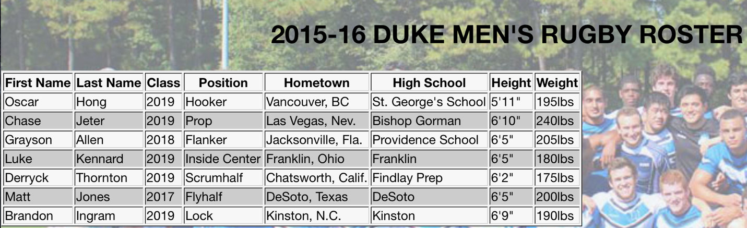Before:
  + 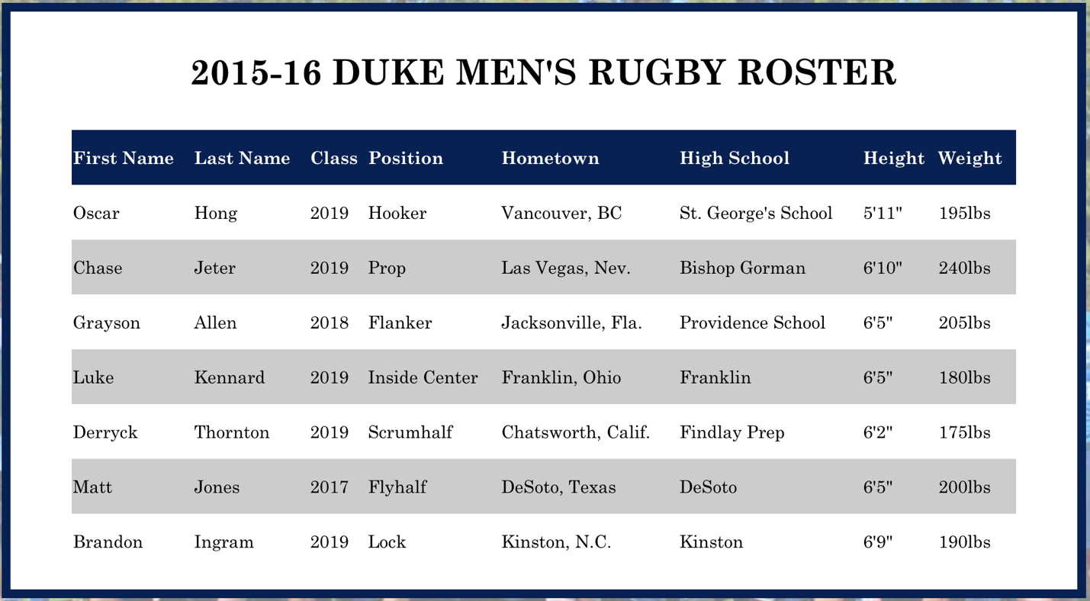After:

**Creativity:**

*The "Welcome To Duke Rugby" image is nice, but I daresay you didn't create that?*

* I thought that we are allowed to incorporate graphic design components into our website so created the image in Photoshop myself. I will include the PSD file in the folder.

*Try to spruce up pages to do more with multimedia. Two pages of just solid blocks of text (even if it is Abraham Lincoln) just is tough to get through. At the max, the Captain's Message page makes sense as a solid block of text, but the Club History page (or is this the About page?) shouldn't be.*

* Captain’s Message and Club History have been merged under About. This was for simplicity as users who want to learn about the club will likely want to know both pieces of information.
* I had this exact concern when I submitted the first version of my website. At that time, I didn’t know where I could find images of the team (I am new this year so I do not have any photos myself). After I found a few good photos on Facebook, I used them to break up the large chunks of text in the Club History section. Now it has more of a blog-entry style and is more visually interesting.
* Captain’s Message now includes a portrait of the captain himself.

*Pretty good color scheme.*

* Thank you!

*Good variety of pages.*

* Thank you!

**Program quality:**

*Some syntax errors. Use the w3 validator to catch these.*

* Used W3 validator to fix syntax errors (namely adding alt attribute to photos)

*Don't use inline styling or equivalent (e.g. style="" or bgcolor="")*

* Moved inline styling to style.css file with classes and id’s

*If using <header> and the like, use <footer> and the like, too (stay consistent)*

* All pages are now consistent with the following structure:
  + <body>
    - <container>
      * <header>
      * <content>
      * <footer>

*When using multiword fonts, put quotes around them ("Helvetica Neue" instead of Helvetica Neue)*

* Fixed!

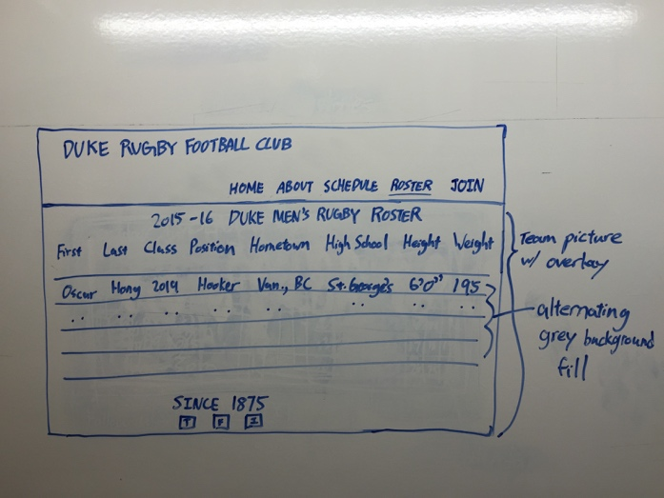**Website Storyboard:**

